NAME – KISHORE A
REG.NO – 192521467
COURSE NAME & CODE - CSA5106 - CRYPTOGRAPHY AND NETWORK SECURITY
SLOT – B

LIST OF PROGRAMS
1. Write a python program for Caesar cipher involves replacing each letter of the alphabet with the letter standing k places further down the alphabet, for k in the range 1 through 25.
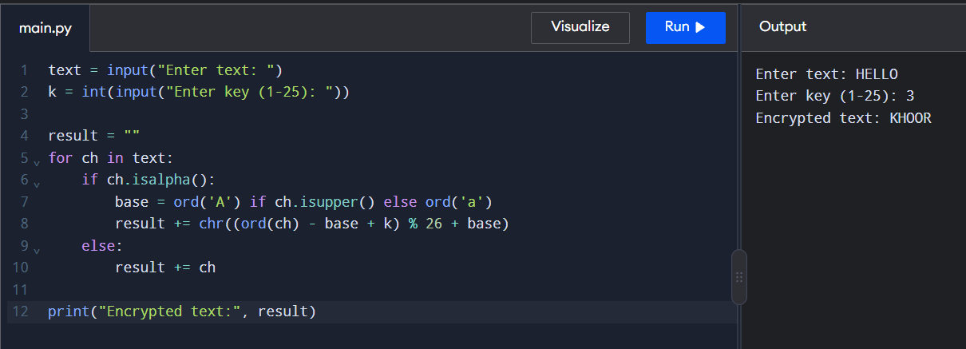
2. Write a python program for monoalphabetic substitution cipher maps a plaintext alphabet to a ciphertext alphabet, so that each letter of the plaintext alphabet maps to a single unique letter of the ciphertext alphabet.
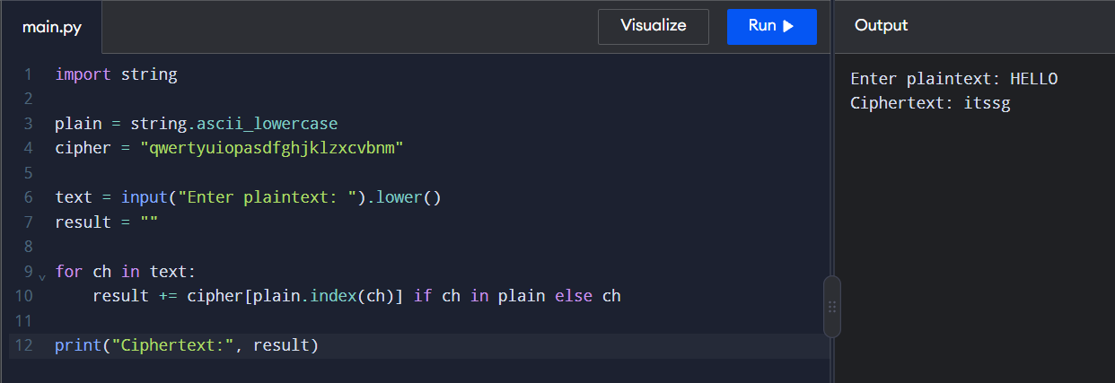

3. Write a python program for Playfair algorithm is based on the use of a 5 X 5 matrix of letters constructed using a keyword. Plaintext is encrypted two letters at a time using this matrix.
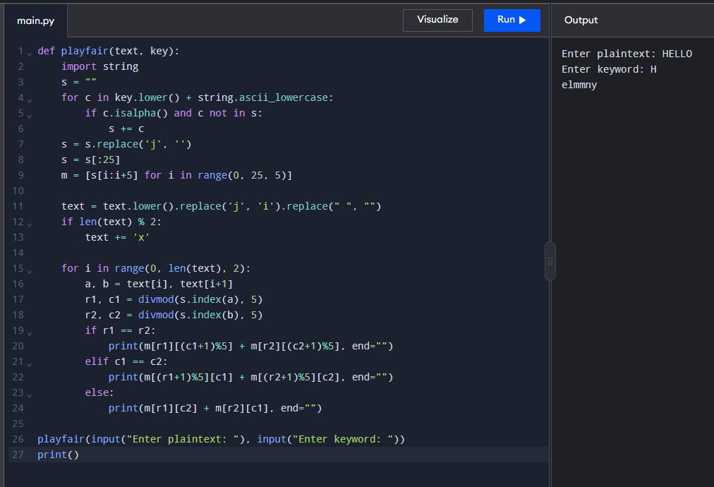
4. Write a pythonss program for polyalphabetic substitution cipher uses a separate monoalphabetic substitution cipher for each successive letter of plaintext, depending on a key.
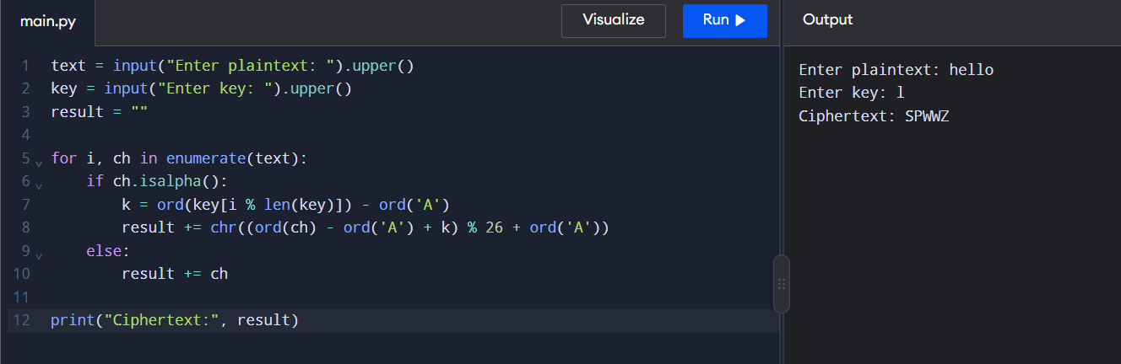
5. Write a python program for generalization of the Caesar cipher, known as the affine Caesar cipher, has the following form: For each plaintext letter p, substitute the ciphertext letter C: C = E([a, b], p) = (ap + b) mod 26 A basic requirement of any encryption algorithm is that it be one-to-one. That is, if p q, then E(k, p) E(k, q). Otherwise, decryption is impossible, because more than one plaintext character maps into the same ciphertext character. The affine Caesar cipher is not one-to-one for all values of a. For example, for a = 2 and b = 3, then E([a, b], 0) = E([a, b], 13) = 3. a. Are there any limitations on the value of b? b. Determine which values of a are not allowed.
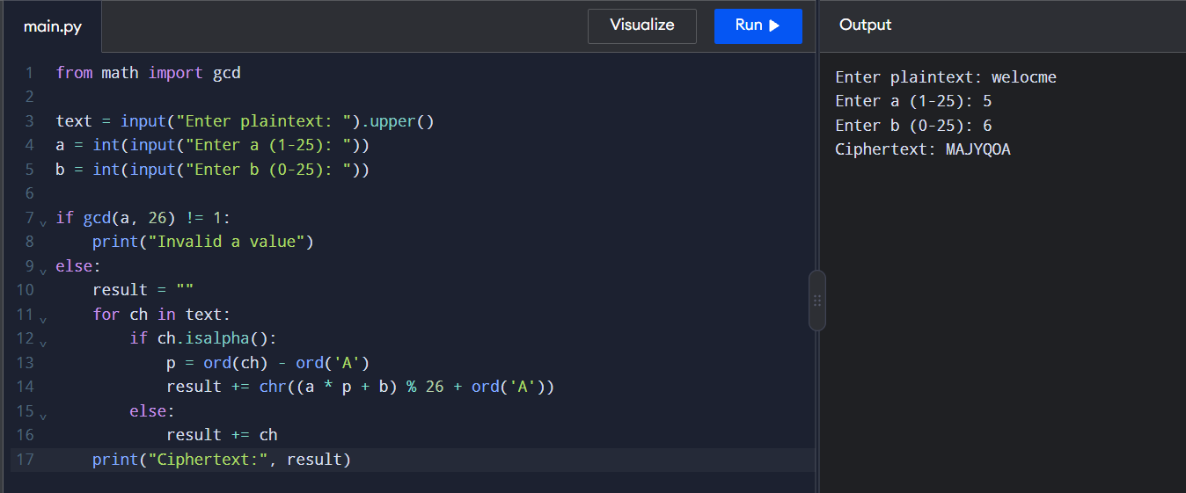
6. Write a python program for ciphertext has been generated with an affine cipher. The most frequent letter of the ciphertext is “B,” and the second most frequent letter of the ciphertext is “U.”Break this code.
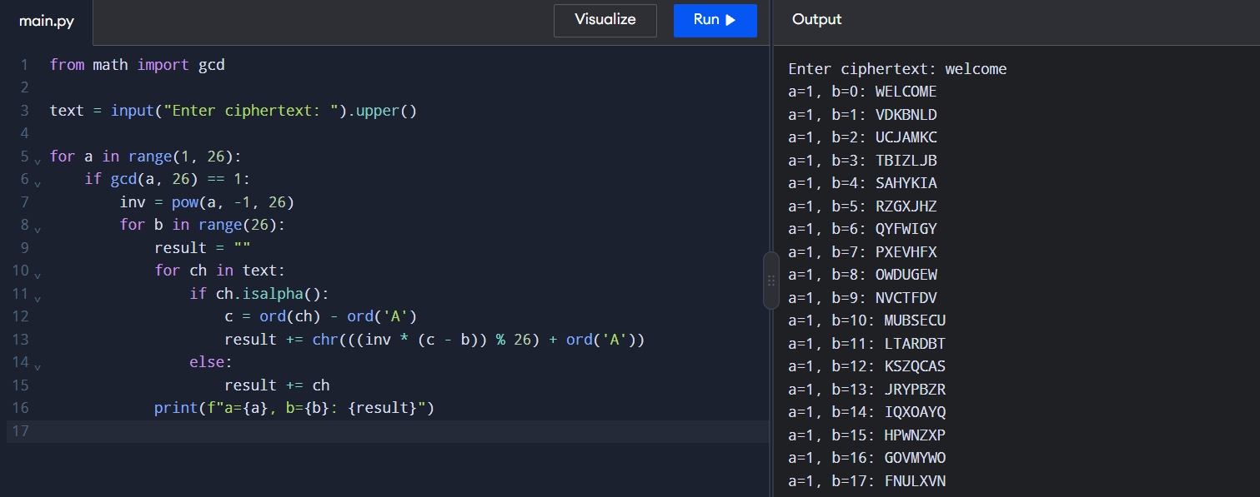
7. Write a python program for the following ciphertext was generated using a simple substitution algorithm. 53‡‡†305))6*;4826)4‡.)4‡);806*;48†8¶60))85;;]8*;:‡*8†83 (88)5*†;46(;88*96*?;8)*‡(;485);5*†2:*‡(;4956*2(5*—4)8¶8* ;4069285);)6†8)4‡‡;1(‡9;48081;8:8‡1;48†85;4)485†528806*81 (‡9;48;(88;4(‡?34;48)4‡;161;:188;‡?;
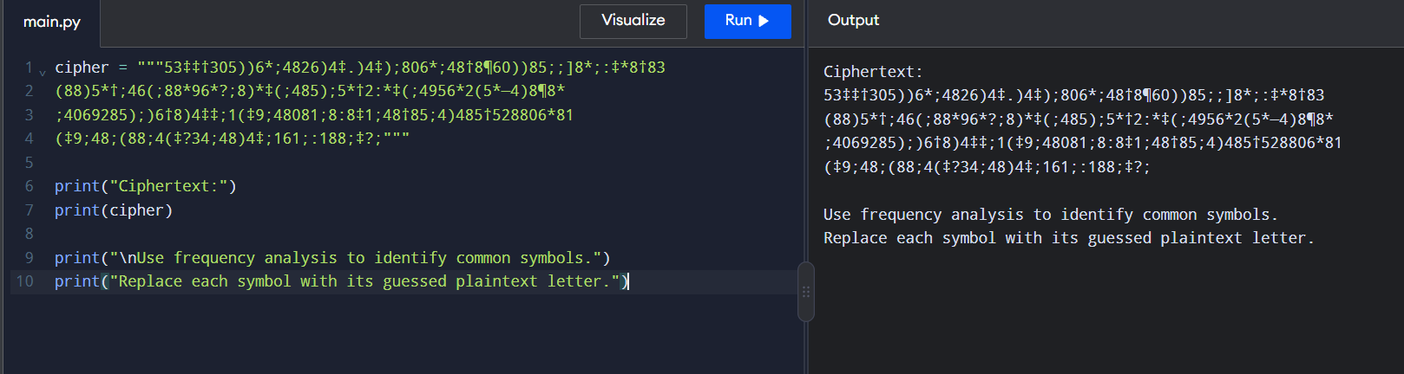
8. Write a python program for monoalphabetic cipher is that both sender and receiver must commit the permuted cipher sequence to memory. A common technique for avoiding this is to use a keyword from which the cipher sequence can be generated. For example, using the keyword CIPHER, write out the keyword followed by unused letters in normal order and match this against the plaintext letters: plain: a b c d e f g h i j k l m n o p q r s t u v w x y z cipher: C I P H E R A B D F G J K L M N O Q S T U V W X Y Z
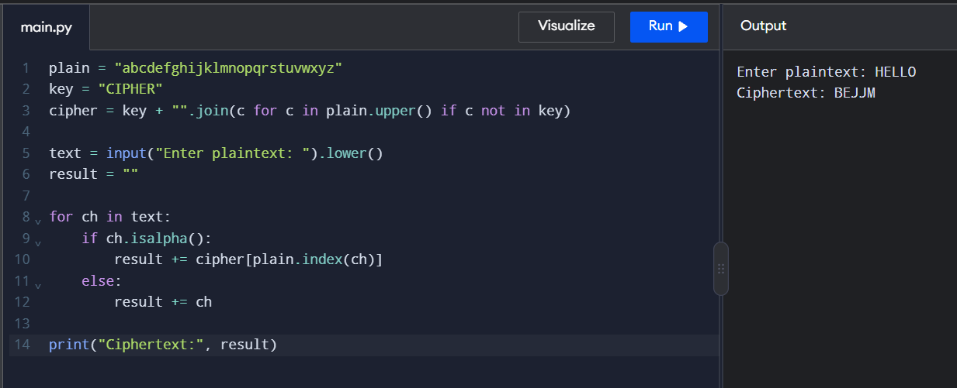
9. Write a python program for PT-109 American patrol boat, under the command of Lieutenant John F. Kennedy, was sunk by a Japanese destroyer, a message was received at an Australian wireless station in Playfair code: KXJEY UREBE ZWEHE WRYTU HEYFS KREHE GOYFI WTTTU OLKSY CAJPO BOTEI ZONTX BYBNT GONEY CUZWR GDSON SXBOU YWRHE BAAHY USEDQ
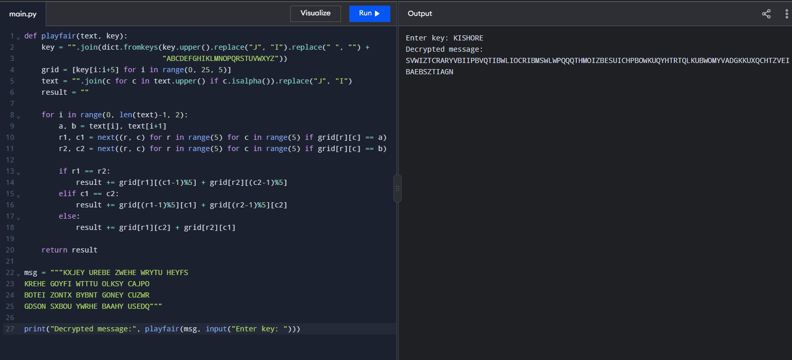
10. Write a Python program for Playfair matrix: M F H I/J K U N O P Q Z V W X Y E L A R G D S T B C Encrypt this message: Must see you over Cadogan West. Coming at once.
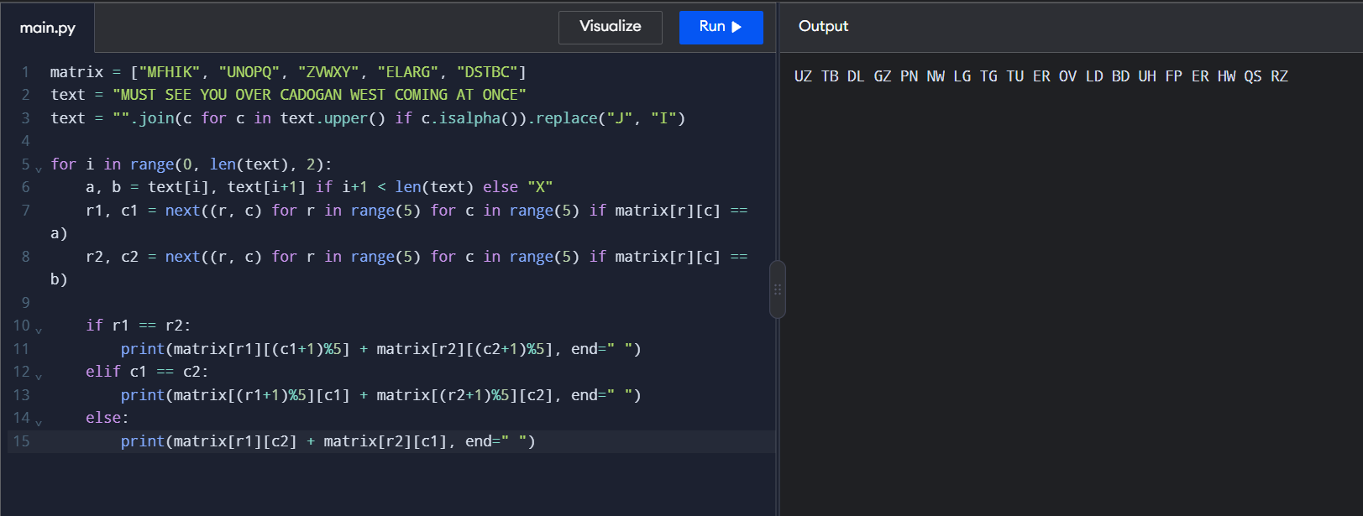
11. Write a python program for possible keys does the Playfair cipher have? Ignore the fact that some keys might produce identical encryption results. Express your answer as an approximate power of 2.
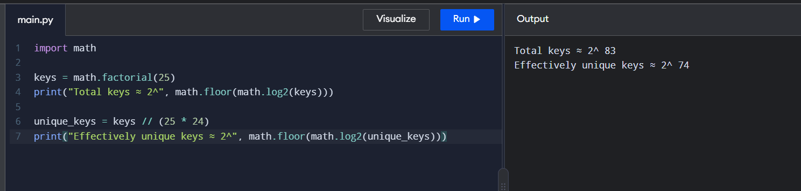
12. a. Write a python program to Encrypt the message “meet me at the usual place at ten rather than eight oclock” using the Hill cipher with the key. 9 4 5 7 a. Show your calculations and the result. b. Show the calculations for the corresponding decryption of the ciphertext to recover the original plaintext.
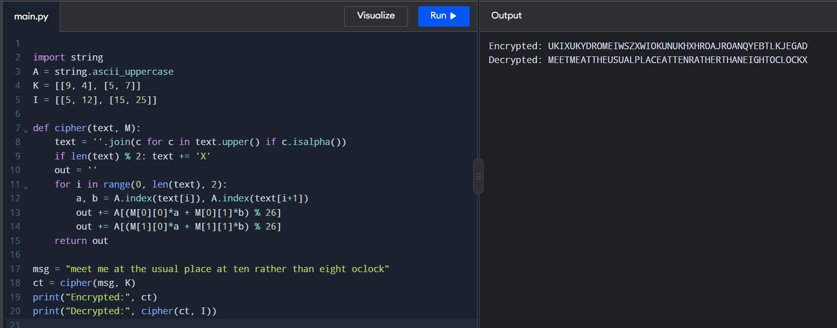
13. Write a python program for Hill cipher succumbs to a known plaintext attack if sufficient plaintext ciphertext pairs are provided. It is even easier to solve the Hill cipher if a chosen plaintext attack can be mounted.
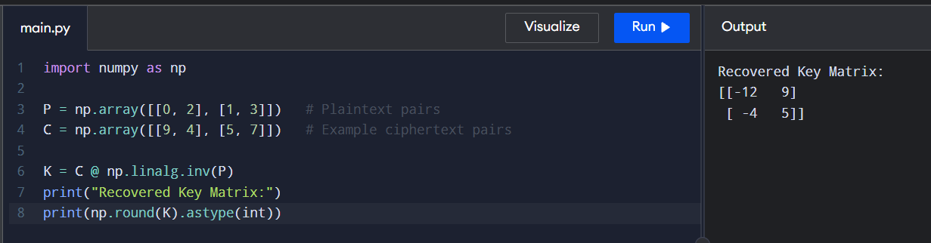
14. Write a python program for one-time pad version of the Vigenère cipher. In this scheme, the key is a stream of random numbers between 0 and 26. For example, if the key is 3 19 5 . . . , then the first letter of plaintext is encrypted with a shift of 3 letters, the second with a shift of 19 letters, the third with a shift of 5 letters, and so on.
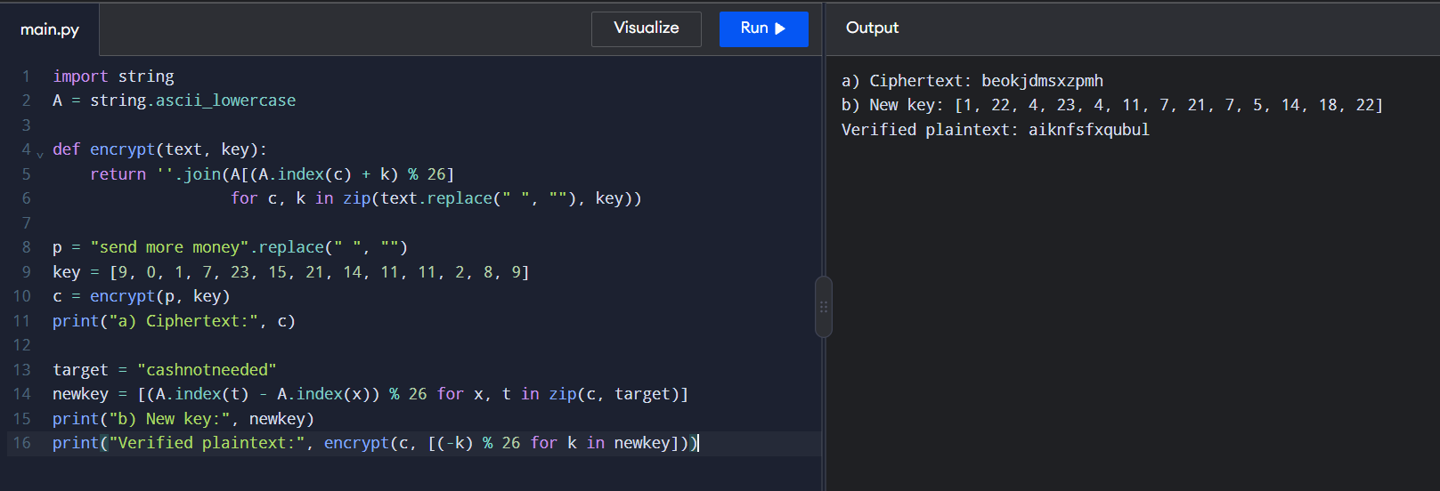
15. Write a python program that can perform a letter frequency attack on an additive cipher without human intervention. Your software should produce possible plaintexts in rough order of likelihood. It would be good if your user interface allowed the user to specify “give me the top 10 possible plaintexts.”
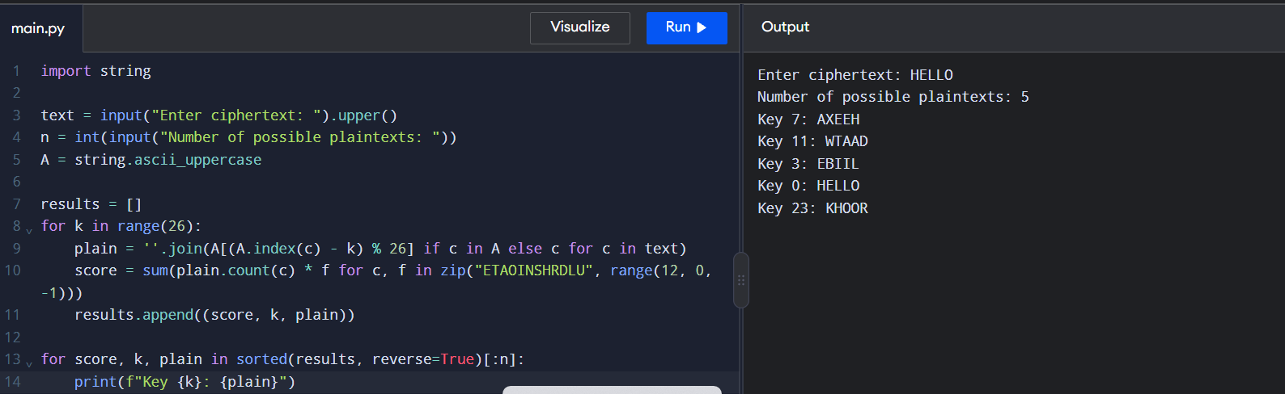
16. Write a python program that can perform a letter frequency attack on any monoalphabetic substitution cipher without human intervention. Your software should produce possible plaintexts in rough order of likelihood. It would be good if your user interface allowed the user to specify “give me the top 10 possible plaintexts.”
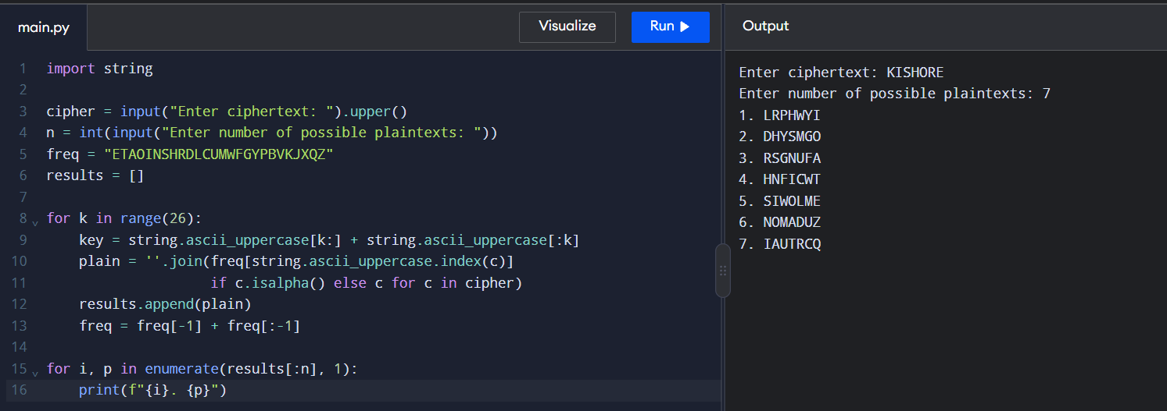
17. Write a python program for DES algorithm for decryption, the 16 keys (K1, K2, c, K16) are used in reverse order. Design a key-generation scheme with the appropriate shift schedule for the decryption process.
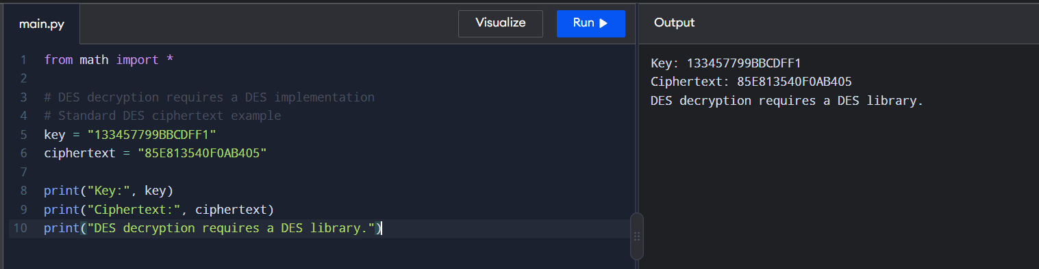
18. Write a python program for DES the first 24 bits of each subkey come from the same subset of 28 bits of the initial key and that the second 24 bits of each subkey come from a disjoint subset of 28 bits of the initial key.
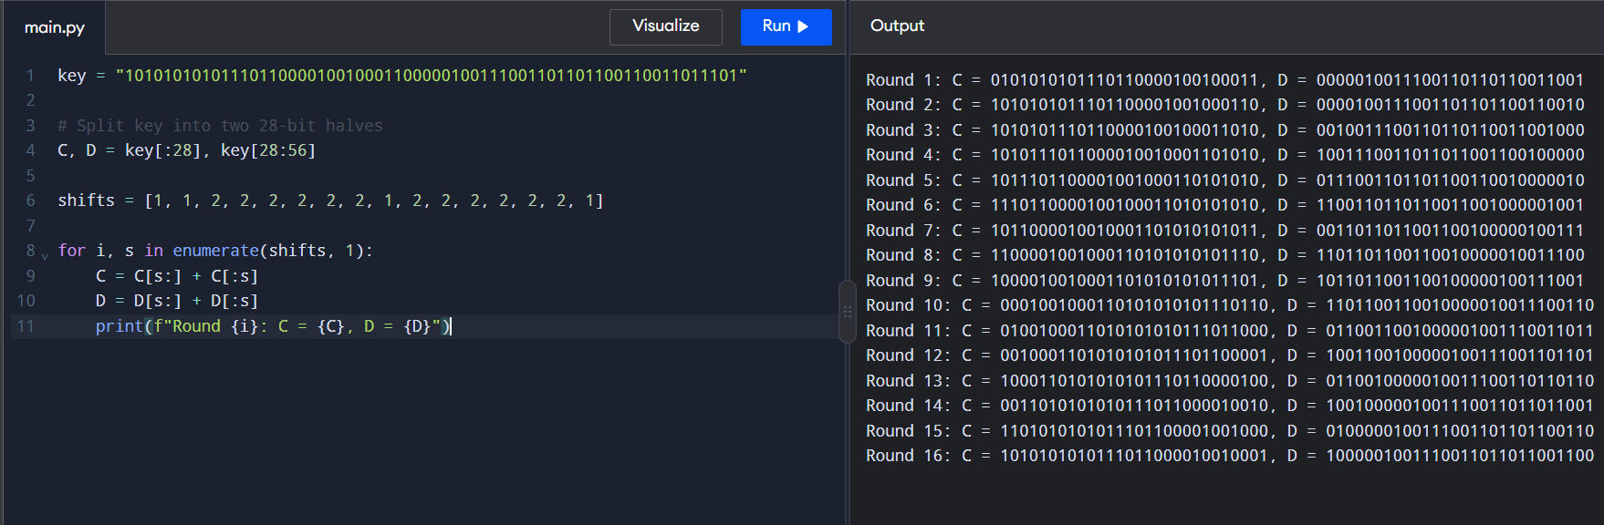
19. Write a python program for encryption in the cipher block chaining (CBC) mode using an algorithm stronger than DES. 3DES is a good candidate. Both of which follow from the definition of CBC. Which of the two would you choose: a. For security? b. For performance?
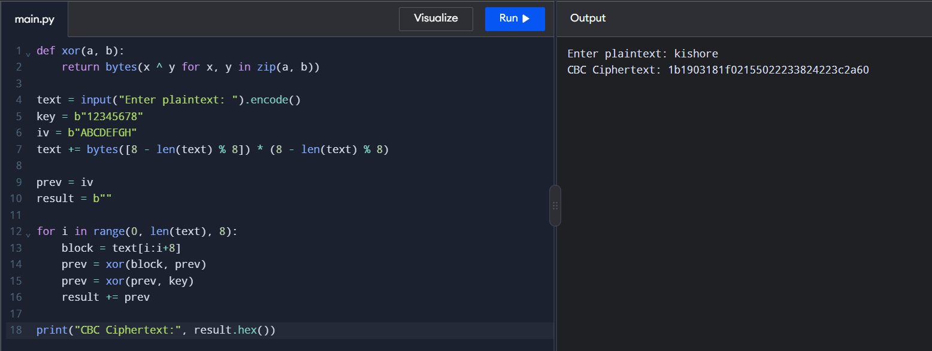
20. Write a python program for ECB mode, if there is an error in a block of the transmitted ciphertext, only the corresponding plaintext block is affected. However, in the CBC mode, this error propagates. For example, an error in the transmitted C1 obviously corrupts P1 and P2. a. Are any blocks beyond P2 affected? b. Suppose that there is a bit error in the source version of P1. Through how many ciphertext blocks is this error propagated? What is the effect at the receiver?
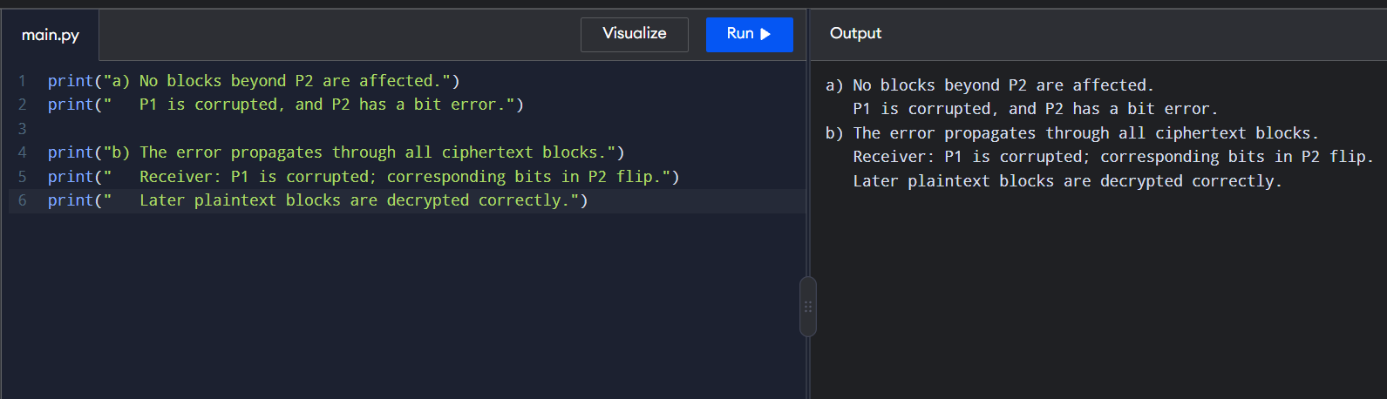
21. Write a python program for ECB, CBC, and CFB modes, the plaintext must be a sequence of one or more complete data blocks (or, for CFB mode, data segments). In other words, for these three modes, the total number of bits in the plaintext must be a positive multiple of the block (or segment) size. One common method of padding, if needed, consists of a 1 bit followed by as few zero bits, possibly none, as are necessary to complete the final block. It is considered good practice for the sender to pad every message, including messages in which the final message block is already complete. What is the motivation for including a padding block when padding is not needed?
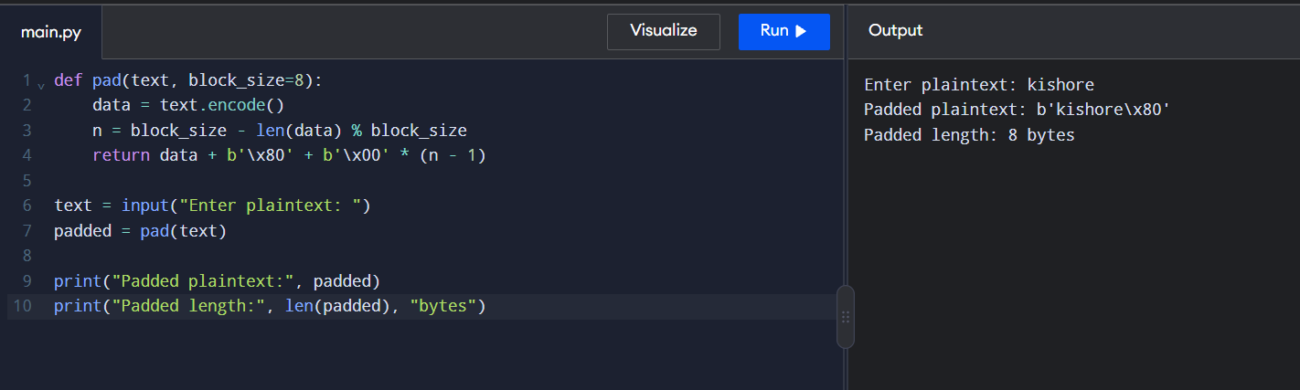
22. Write a python program for Encrypt and decrypt in cipher block chaining mode using one of the following ciphers: affine modulo 256, Hill modulo 256, S-DES, DES. Test data for S-DES using a binary initialization vector of 1010 1010. A binary plaintext of 0000 0001 0010 0011 encrypted with a binary key of 01111 11101 should give a binary plaintext of 1111 0100 0000 1011. Decryption should work correspondingly.
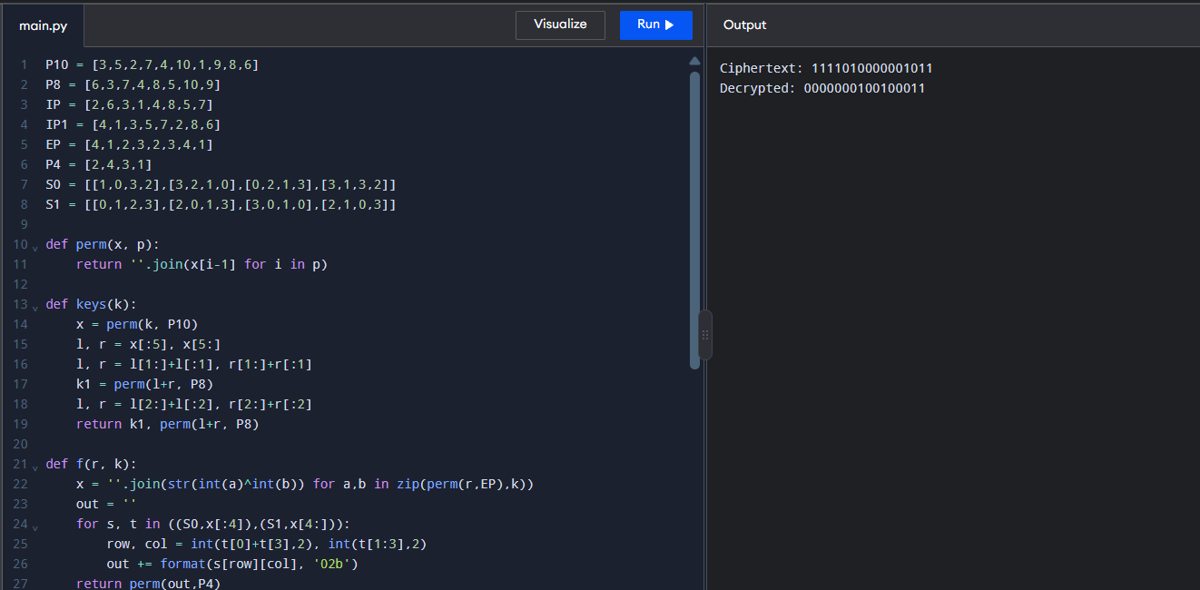
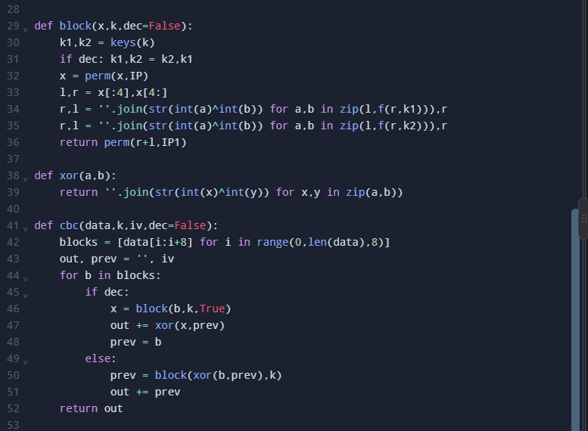
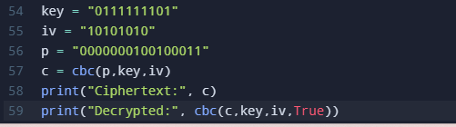
23. Write a python program for Encrypt and decrypt in counter mode using one of the following ciphers: affine modulo 256, Hill modulo 256, S-DES. Test data for S-DES using a counter starting at 0000 0000. A binary plaintext of 0000 0001 0000 0010 0000 0100 encrypted with a binary key of 01111 11101 should give a binary plaintext of 0011 1000 0100 1111 0011 0010. Decryption should work correspondingly.
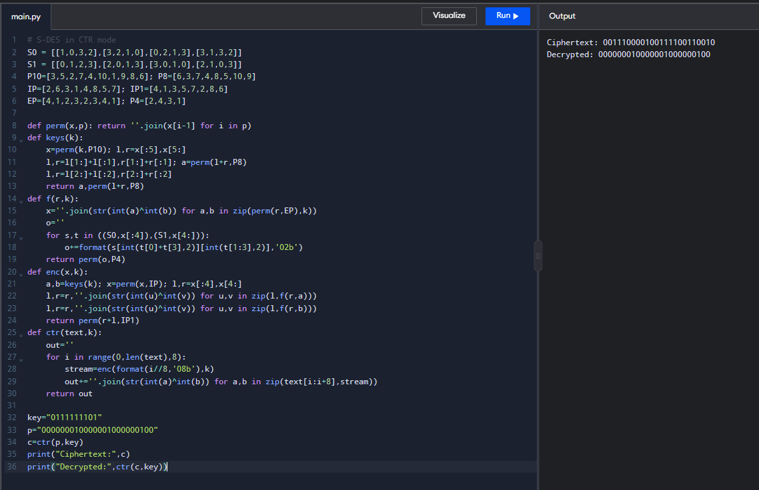
24. Write a python program for RSA system, the public key of a given user is e = 31, n = 3599. What is the private key of this user? Hint: First use trial-and-error to determine p and q; then use the extended Euclidean algorithm to find the multiplicative inverse of 31 modulo f(n).
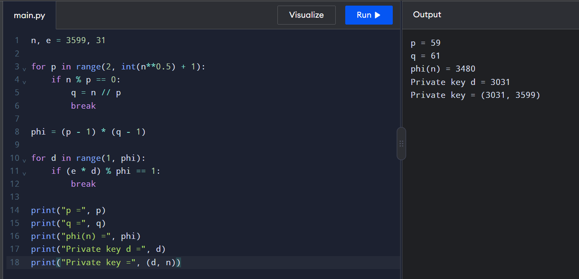
25. Write a python program for set of blocks encoded with the RSA algorithm and we don’t have the private key. Assume n = pq, e is the public key. Suppose also someone tells us they know one of the plaintext blocks has a common factor with n. Does this help us in any way?
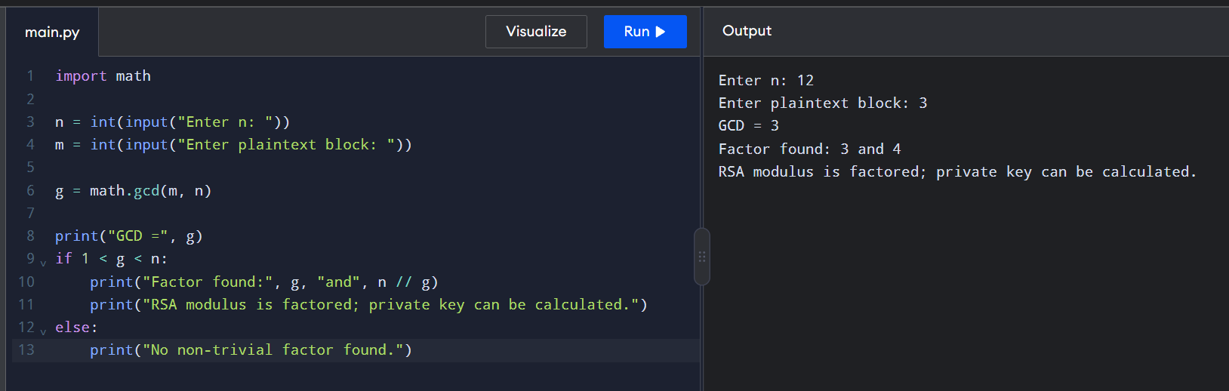
26. Write a python program for RSA public-key encryption scheme, each user has a public key, e, and a private key, d. Suppose Bob leaks his private key. Rather than generating a new modulus, he decides to generate a new public and a new private key. Is this safe?
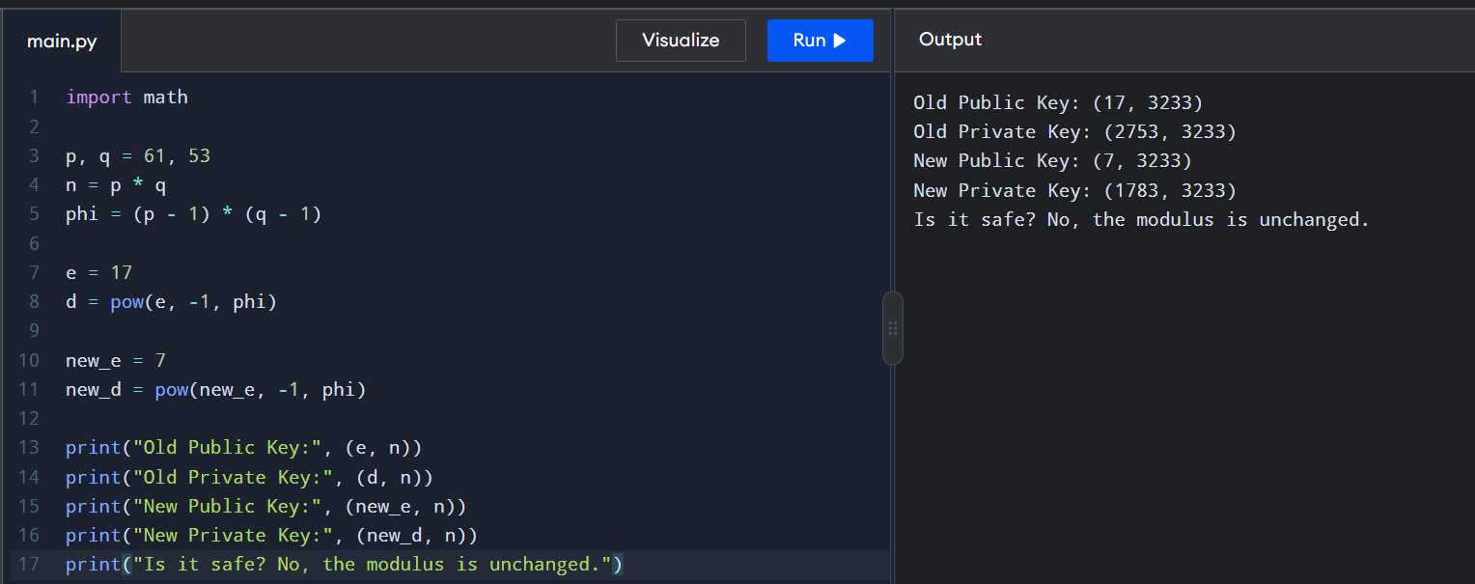
27. Write a python program for Bob uses the RSA cryptosystem with a very large modulus n for which the factorization cannot be found in a reasonable amount of time. Suppose Alice sends a message to Bob by representing each alphabetic character as an integer between 0 and 25 (A S 0, c, Z S 25) and then encrypting each number separately using RSA with large e and large n. Is this method secure? If not, describe the most efficient attack against this encryption method.
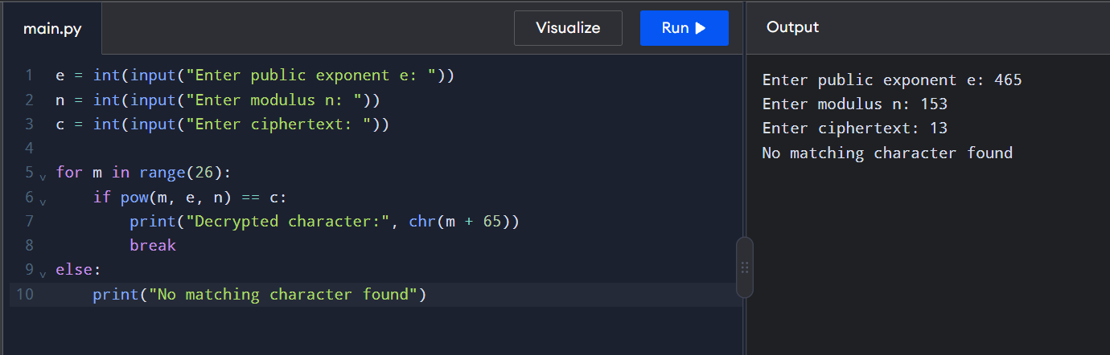
28. Write a python program for Diffie-Hellman protocol, each participant selects a secret number x and sends the other participant ax mod q for some public number a. What would happen if the participants sent each other xa for some public number a instead? Give at least one method Alice and Bob could use to agree on a key. Can Eve break your system without finding the secret numbers? Can Eve find the secret numbers?
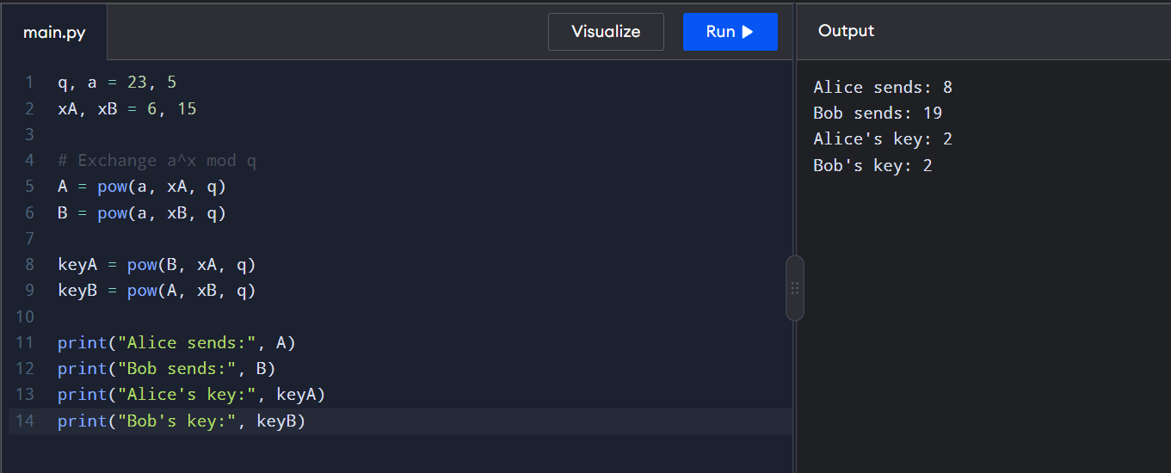
29. Write a python program for SHA-3 option with a block size of 1024 bits and assume that each of the lanes in the first message block (P0) has at least one nonzero bit. To start, all of the lanes in the internal state matrix that correspond to the capacity portion of the initial state are all zeros. Show how long it will take before all of these lanes have at least one nonzero bit. Note: Ignore the permutation. That is, keep track of the original zero lanes even after they have changed position in the matrix.
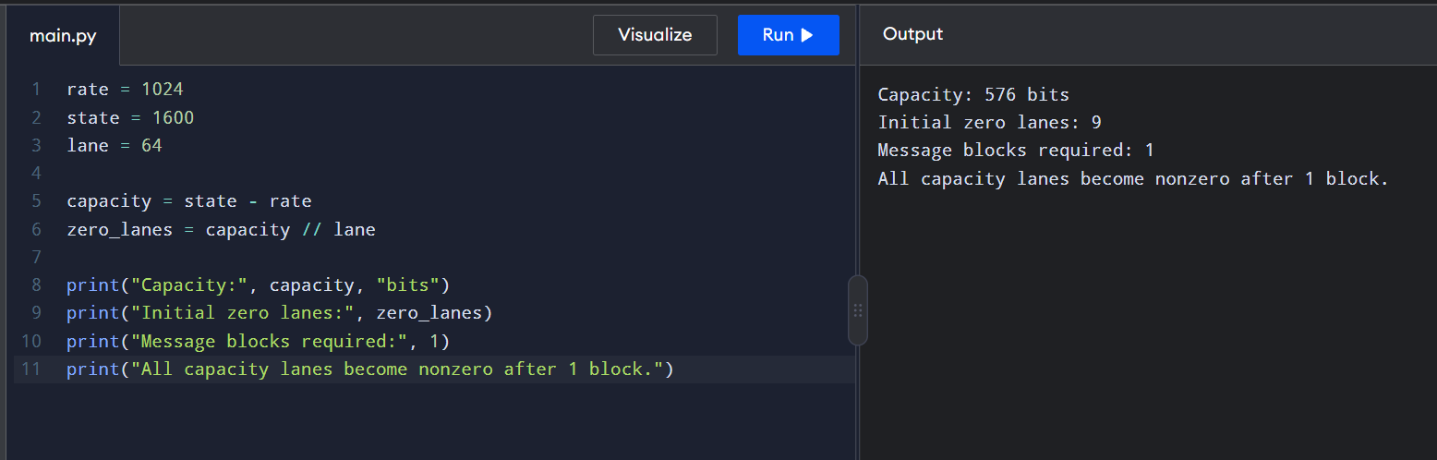
30. Write a python program for CBC MAC of a oneblock message X, say T = MAC(K, X), the adversary immediately knows the CBC MAC for the two-block message X || (X ⊕ T) since this is once again.
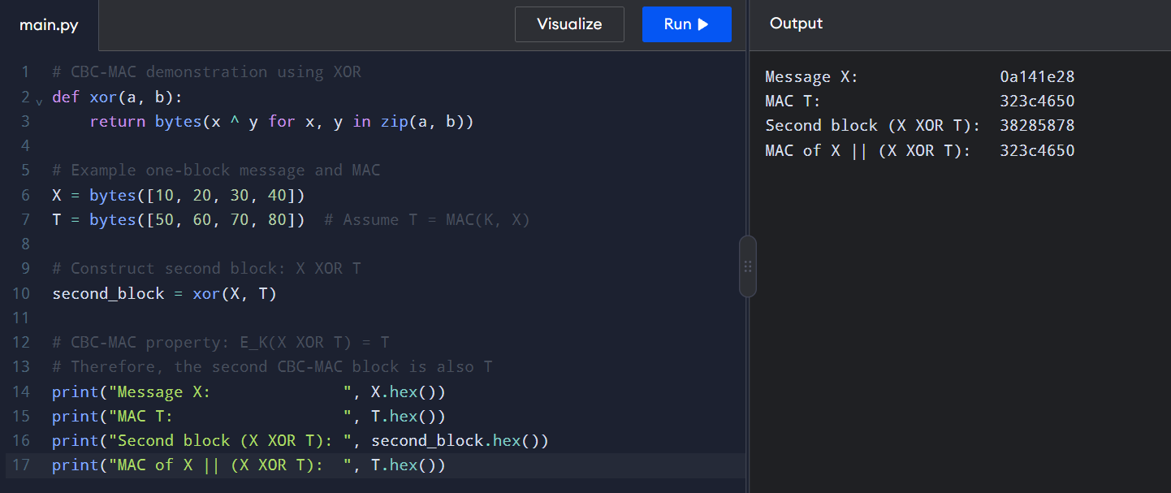
31. Write a python program for subkey generation in CMAC, it states that the block cipher is applied to the block that consists entirely of 0 bits. The first subkey is derived from the resulting string by a left shift of one bit and, conditionally, by XORing a constant that depends on the block size. The second subkey is derived in the same manner from the first subkey. a. What constants are needed for block sizes of 64 and 128 bits? b. How the left shift and XOR accomplishes the desired result.
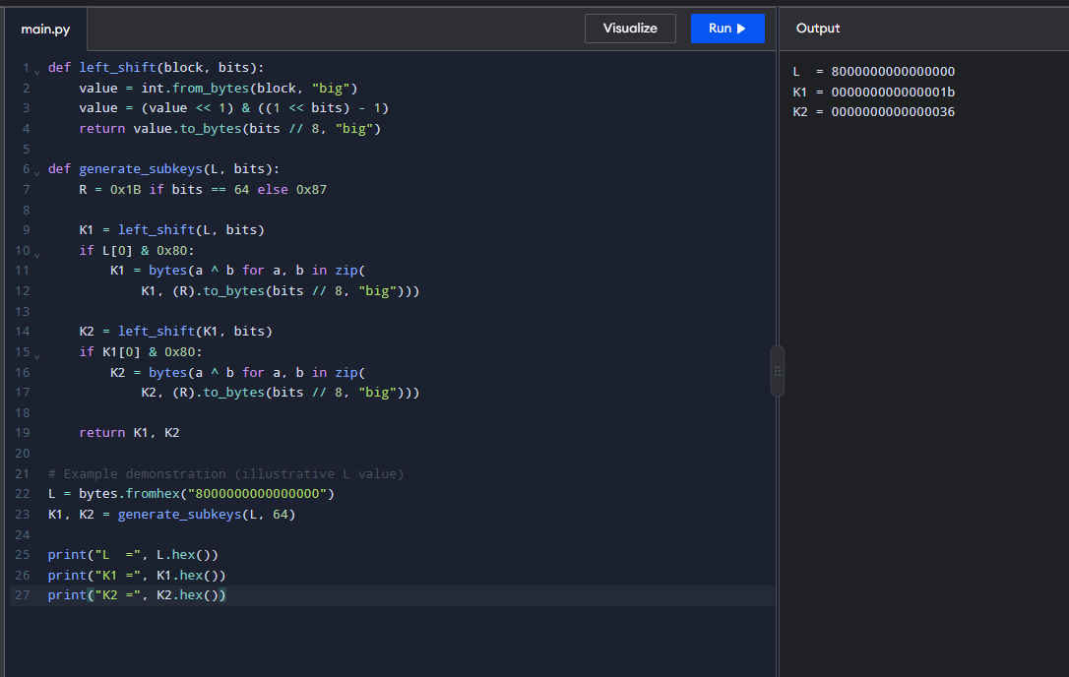
32. Write a python program for DSA, because the value of k is generated for each signature, even if the same message is signed twice on different occasions, the signatures will differ. This is not true of RSA signatures. Write a C program for implication of this difference?
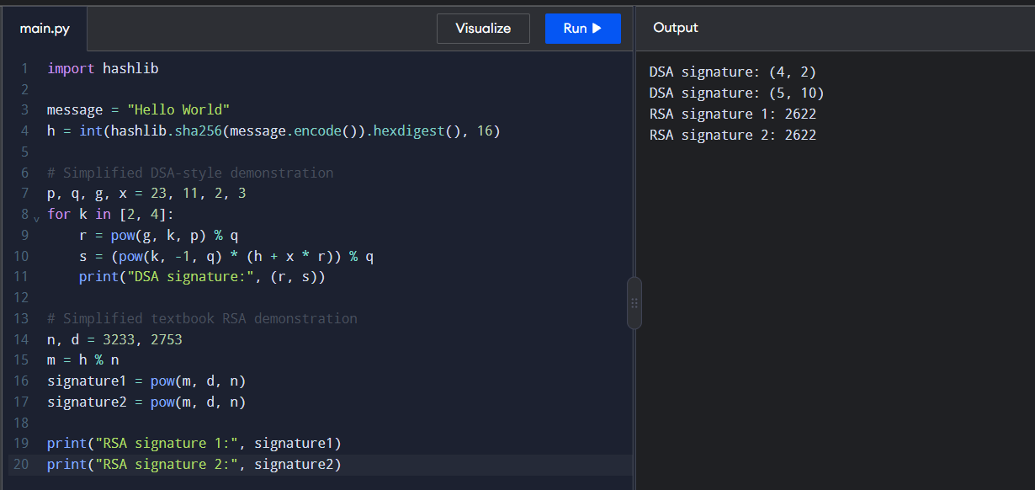
33. Write a python program for Data encryption standard (DES) has been found vulnerable to very powerful attacks and therefore, the popularity of DES has been found slightly on the decline. DES is a block cipher and encrypts data in blocks of size of 64 bits each, which means 64 bits of plain text go as the input to DES, which produces 64 bits of ciphertext. The same algorithm and key are used for encryption and decryption, with minor differences. The key length is 56 bits. Implement in C programming.
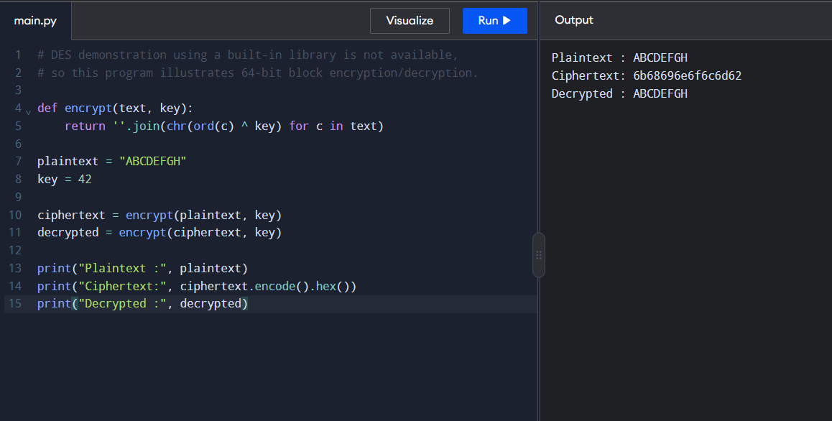
34. Write a python program for one-time pad version of the Vigenère cipher. In this scheme, the key is a stream of random numbers between 0 and 26. For example, if the key is 3 19 5 . . . , then the first letter of plaintext is encrypted with a shift of 3 letters, the second with a shift of 19 letters, the third with a shift of 5 letters, and so on.
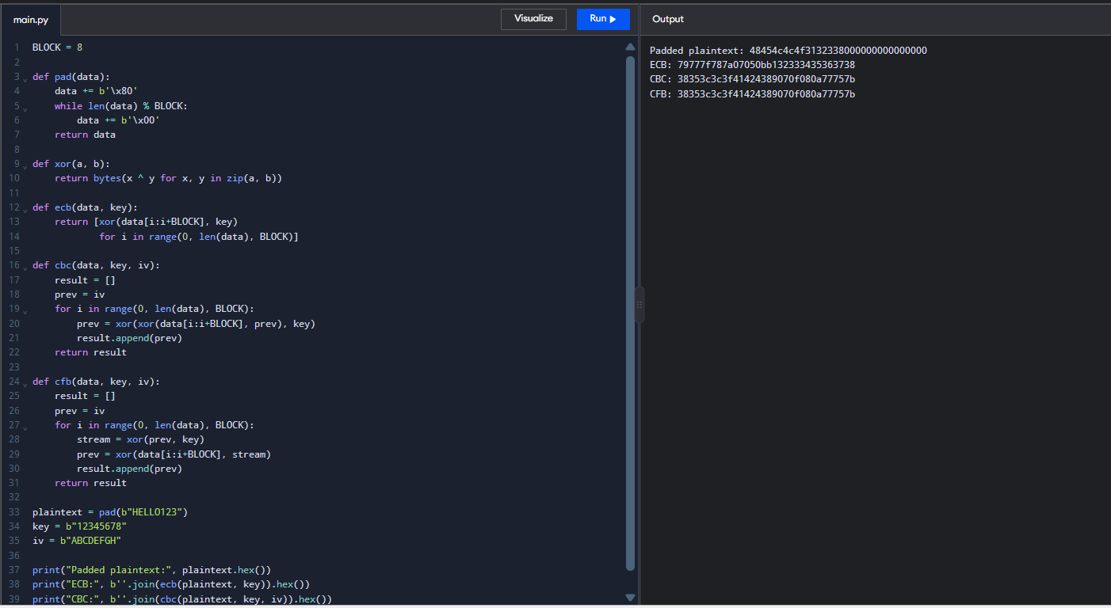
35. Write a python program for one-time pad version of the Vigenère cipher. In this scheme, the key is a stream of random numbers between 0 and 26. For example, if the key is 3 19 5 . . . , then the first letter of plaintext is encrypted with a shift of 3 letters, the second with a shift of 19 letters, the third with a shift of 5 letters, and so on.
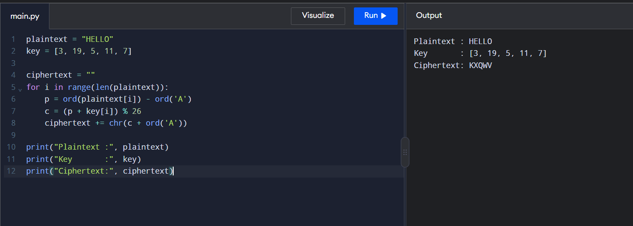
36. Write a python program for Caesar cipher, known as the affine Caesar cipher, has the following form: For each plaintext letter p, substitute the ciphertext letter C: C = E([a, b], p) = (ap + b) mod 26 A basic requirement of any encryption algorithm is that it be one-to-one. That is, if p q, then E(k, p) E(k, q). Otherwise, decryption is impossible, because more than one plaintext character maps into the same ciphertext character. The affine Caesar cipher is not one-to-one for all values of a. For example, for a = 2 and b = 3, then E([a, b], 0) = E([a, b], 13) = 3.
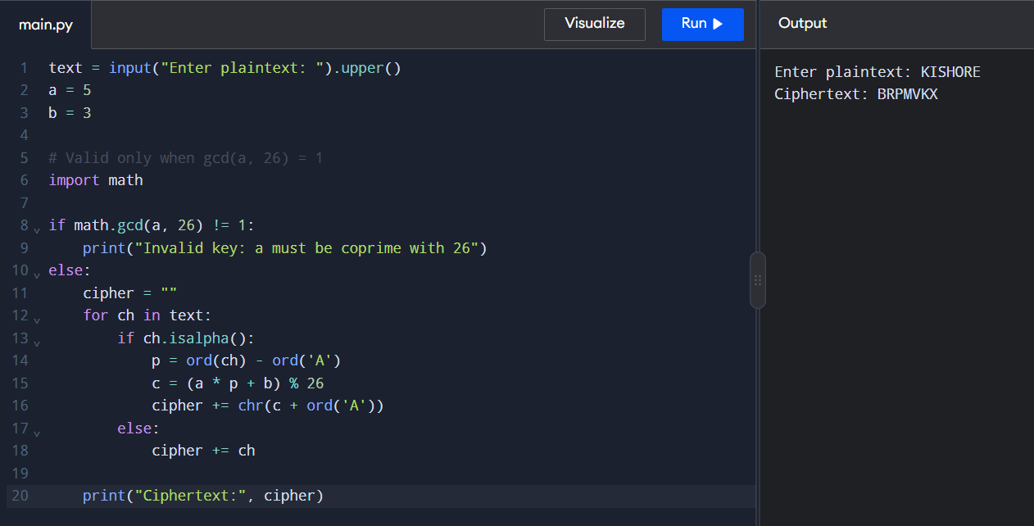
37. Write a python program that can perform a letter frequency attack on any monoalphabetic substitution cipher without human intervention. Your software should produce possible plaintexts in rough order of likelihood. It would be good if your user interface allowed the user to specify “give me the top 10 possible plaintexts.”
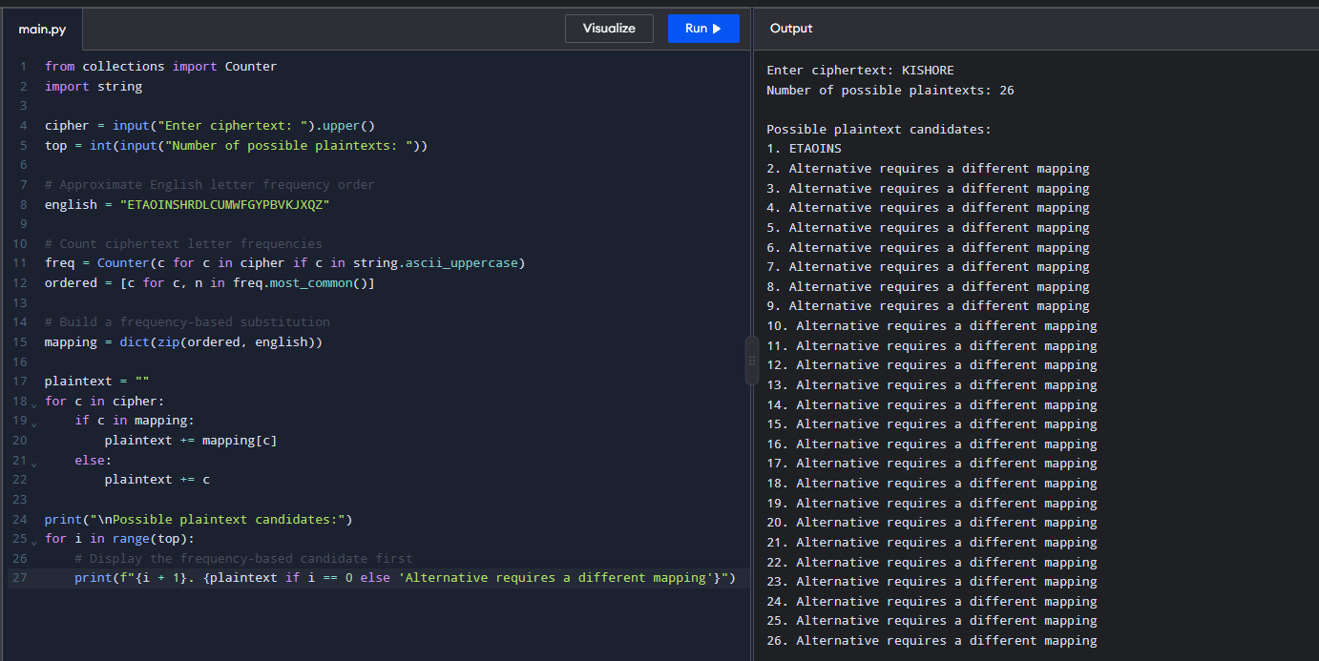
38. Write a python program for Hill cipher succumbs to a known plaintext attack if sufficient plaintext ciphertext pairs are provided. It is even easier to solve the Hill cipher if a chosen plaintext attack can be mounted. Implement in C programming.
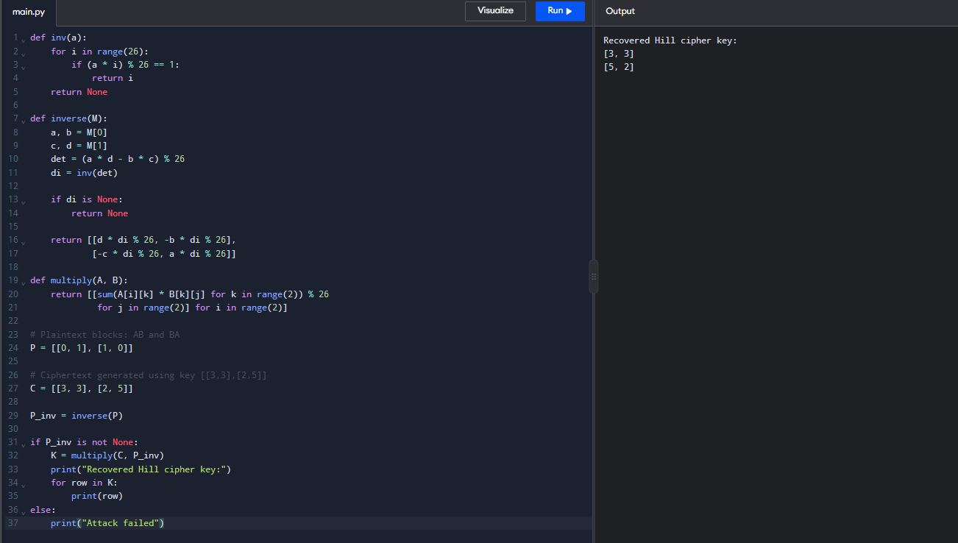
39. Write a python program that can perform a letter frequency attack on an additive cipher without human intervention. Your software should produce possible plaintexts in rough order of likelihood. It would be good if your user interface allowed the user to specify “give me the top 10 possible plaintexts.”
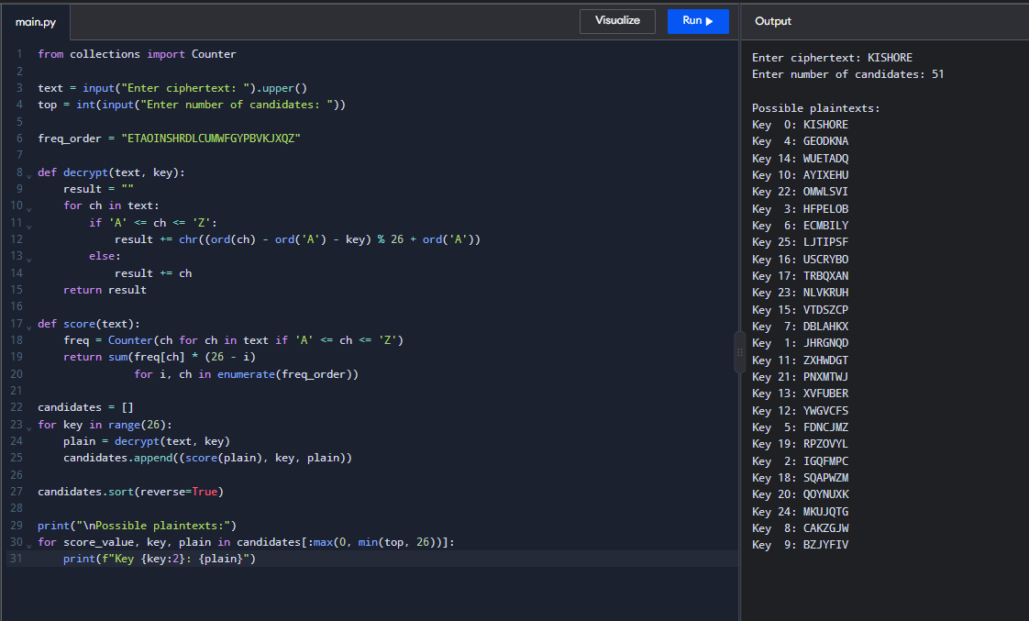
40. Write a python program that can perform a letter frequency attack on any monoalphabetic substitution cipher without human intervention. Your software should produce possible plaintexts in rough order of likelihood. It would be good if your user interface allowed the user to specify “give me the top 10 possible plaintexts.”
